WHAT ARE SMENCILS
Scento Inc roll sheets of newspaper tightly around the coloured writing cores until pencils of typical thickness are formed. Then they’re hardened – allowing them to be sharpened just like wood pencils. Next, we soak them with our gourmet liquid scents (made by an award winning fragrance company). Once they’re dry, we apply the stickers around them that identify which scent was infused into each Coloured Smencil. Lastly, we put each Coloured Smencil into its own corn-based biodegradable Freshness Tube.
You can read more about this Australian Company at www.smencils.com.au
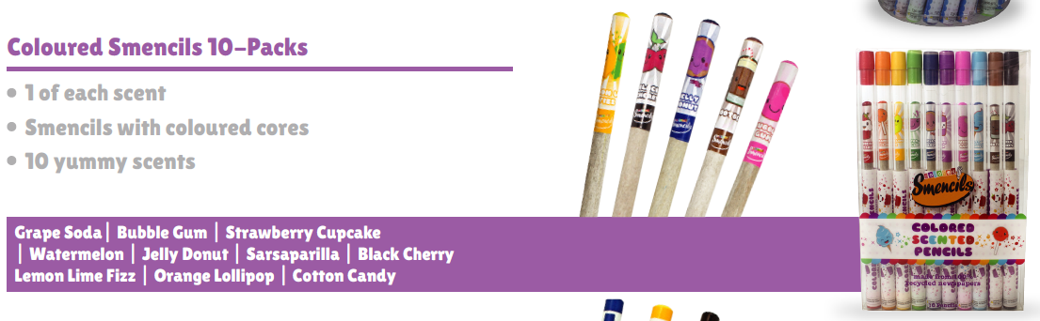
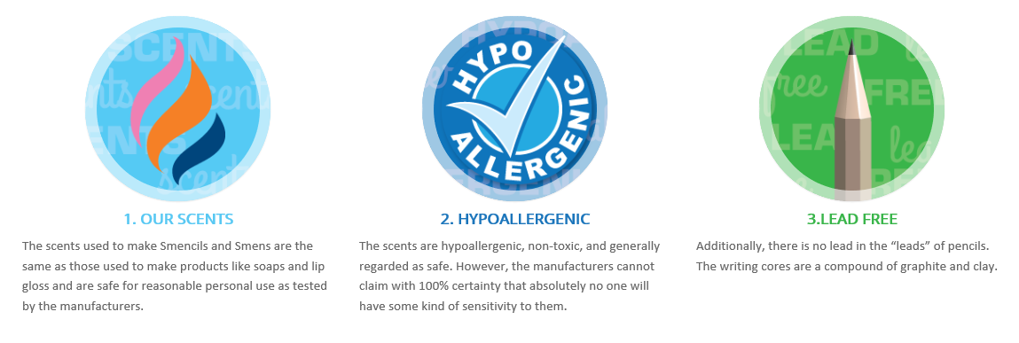
These awesome smencils are available to St Michael’s families for the great price of $15.95 per pack of 10 smencils. Perfect for Christmas presents or stocking fillers.
NAME : |  | CONTACT NUMBER :
NUMBER OF PACKS | PRICE PER PACKET | TOTAL COST
 | $15.95
PAYMENT OPTIONS | Cash or Bank Transfer to St Michael’s School | Amount | $
Bank Transfer | Account Name: XXX | BSB: | XXX
Reference for transfer | YOURSURNAME+SMENCILS | Account No: | XXX
NOTE : ALL FUNDS FROM THIS CHRISTMAS SMENCIL FUNDRAISER WILL GO TOWARDS THE PURCHASE OF NEW FURNITURE FOR THE ST MICHAEL’s LIBRARY

